Ricky Nandhra - 220076203
Ant Colony Simulation using Unity
Supervisors
Chloe Barnes - c.barnes1@aston.ac.uk
Megan Robertson - m.robertson8@aston.ac.uk

Table of Contents
Introduction 2
Background 2
Research Question 3
Planning and Methodology 4
System Design 5
Prototyping 6
Simulation Development 7
Testing Methodology 8
Testing & Results 9
Directionality Testing 10
Obstacles and Directionality Testing 11
Speed of Forming Efficient Paths 12
Accessibilty Testing 14
Evaluation 15
Conclusion 16
References 17
Appendix 18
Assets 24
Resources 24

Introduction
Aristotle’s observation that “the whole is greater than the sum of its parts” is one of the earliest nods to emergent properties. The studies of emergent properties have led to Computational Intelligence (CI); one of the key techniques used within CI is Ant Colony Optimisation (ACO). ACO is a heuristics-based approach to find near optimal solutions in navigating graph-like structures efficiently. ACO achieves this by mimicking simple rules that ants follow, ‘ants deposit pheromone on the ground to mark some favourable path that should be followed by other members of the colony’ (Dorigo, Birattari and Stutzle, 2006). Dorigo published the first ACO variant in 1991 and in the 35 years following Artificial Intelligence (AI) has improved drastically. Generative AI and Large Language Models have become prevalent in the digital world in just 4 years.
My belief is that further studies of emergent properties will allow modern systems to become more robust and scalable – which will be needed with our current growth in AI. Our current physical and data infrastructure is unable to handle the surge in AI, for instance Meta is building a Manhattan sized Data Centre which will have a significant impact on our energy and water usage. Currently de Vries-Gao (2025) suggests that ‘AI system power demand approaching that of a country the size of the United Kingdom’, while the total water consumption was estimated to be 560 billion litres in 2023. The techniques discovered in the 90s were efficient and have held up to modern standards, further research in these areas will likely lead to more efficient methods and could hopefully reduce the footprint of modern AI.
Data, on the other hand, is more widespread. I have seen first-hand that companies who did not manage their data to a high enough standard before the AI surge, such as using multiple spreadsheets instead of a database. Data structures need to be reliable and efficient in order to search through the data better. Companies with data structures which are unsuitable for AI use have turned to AI, to reduce business costs, make their workflows more efficient and to aid in business decisions. AI needs to follow principle of good data in, good data out. Though Slota et al. (2020) argue that ‘systems with “perfect data” for their intended purpose might still be misused or misunderstood’, good data alone might not be enough.

Background
What do ants have to do with data? By using ACO principles, optimisation problems can be approximated with relatively high certainty. One example is the Travelling Salesman Problem, an ‘optimisation problem that is simple to state but very difficult to solve. The problem is to find the shortest tour through a set of N vertices so that each vertex is visited exactly once. This problem is known to be NP-hard and cannot be solved exactly in polynomial time’ (Dahiya and Sangwan, 2018). With more vertices, the time to search every possible route becomes incomprehensibly large, it becomes infeasible to do so. Algorithms like ACO are used in situations like this, ACO is specifically used here because TSP can be reduced to a graph-like structure, just like a folder structure holding data. Michelakos et al. (2011) have pioneered using ACO for data mining. ‘Data Mining, a discipline that consists of techniques for discovering previously unknown, valid patterns and relationships in large data sets, has emerged as an important technology with numerous practical applications, due to wide availability of a vast amount of data’. ACO could be useful within data-driven AI applications due to the vast amount of data.
First the feasibility of this needs to be tested, how well does ACO handle different environments? How can I create different environments to test ACO? I needed to find a tool where I could visualise the ant agents, as well as save and modify different environments. These requirements lead to game engines, software which handles core functionality to this simulation, like visualisation, controlling the individual agents with scripts I can create, while also allowing me to create, modify and save unique and handcrafted environments, generally called levels. There are a wide range of game engines available, typically the top choices are Unity, Unreal Engine and Godot.
There are various pros and cons to each engine. Unreal Engine is typically used for 3D projects, whereas Godot is for 2D projects, however, Unity is used for both 3D and 2D projects. All three use different coding languages, Unity uses C#, Unreal uses C++, while Godot uses a built-in scripting language GDScript. Community wise, Unity by far has the largest, and Godot the smallest. For these reasons I have chosen to use Unity, as I have not used any of the programs or languages before, it would be the best place for me to start, the community aspect was a big influence as I will inevitably become stuck, having a community to fall back on will be a great help when needed. I also chose to do a 2D simulation, it will still complete the same task, while being less resource intensive.
Ants have some emergent behaviours from following their colony’s pheromone trails. A simple behaviour is their positive feedback of good pheromone trails. The more ants that follow a trail, the stronger that trail becomes, so the more ants that follow the trail. However, this interaction can also lead to the colony’s demise. One phenomenon is known as ant milling, where sometimes ‘a group of foragers are separated from the main swarm’ and ‘the separated workers then run in a densely packed circle until they die of exhaustion’ (Delsuc, 2003). If I see emergent properties like an ant mill, then I can confirm that my simulation is working as intended.

Research Question
How does environmental complexity affect problem-solving efficiency in ant colony systems?
In theory, ant colonies are well suited to navigating complex environments, the behaviour of an individual ant is decentralised, while the behaviour of the colony as a whole is self-organised. The whole colony should be able to adapt to any situation, without relying on a centralised controller. Regardless of how complex an environment is, a sufficient simulation with a large enough colony size should be able to navigate maze-like terrain, successfully locate a goal and bring it back to the colony, with the efficiency increasing over time as the pheromone trails become stronger. But what complexities impact efficiency more? By how much? Answering questions like these could significantly improve various use cases of ACO.
One area of improvement would be the case of Mars rovers, rover operators need ‘to account for a one-way time delay of up to 22 minutes.’ NASA also noted that ‘astronauts cannot rely on real-time advice or guidance from mission controllers and must operate with significant autonomy’ (NASA 2025, p12). Deep space missions, no matter how far from Earth will always have to account for some delay, so improving efficiency is of the upmost importance, fully autonomous rovers completing their missions will reduce costs and time, while speeding up potential crewed missions. Some other notable areas impacted by studying what affects the efficiency of in ant colony systems are: logistics and vehicle routing, networking and telecommunications, and bankruptcy predictions according to Zhang, Wang and Ji (2013).

Planning and Methodology
Having chosen software to create my simulation within, as well as having a language picked out for me and knowing what my end goal is, a well formulated plan will allow me to complete this project within the tight deadline. Another factor to consider is that this project is highly uncertain, I will need to learn how to use Unity and C#. Therefore, an iterative and prototype-driven Agile approach is best. This will ensure early experimentation, promoting my own learning, reducing the risk of long-term pitfalls, as well as enabling previous iterations to inform future decision making.
I will use throwaway prototyping – enabling the comparison of alternative solutions as the final design is unclear. This decision will also allow me to have an early minimum viable product (MVP), while learning by doing. Prototyping in this way will allow me to gain much needed clarity to act on the vague ideas, validate what is feasible and what is not within Unity, and I will be allowed to explore and innovate, enabling me to answer the research question.
My own decisions match with the Agile Manifesto – I am prioritising having working software over documentation, I am responding to change due to my lack of knowledge within Unity over following a plan precisely. One key difference is that I am working on this project alone, while typically Agile is used within a whole team, categorised into three roles. As such, I will be adapting Agile methodologies to the best of my ability, it will serve as a baseline rather than something I will follow to the letter.
The reasons above are how I came to the conclusion that I needed to use Agile and throwaway prototyping. Waterfall is best practice when there is a concrete plan, extreme programming is best practice when the project is test-driven. Due to my lack of experience using Unity, both of these methodologies are not best practice, however, later on during my project, some principles from either methodology might prove useful. It is for a similar reason that I cannot use evolutionary prototyping, I will inevitably make mistakes while learning how to use Unity, those mistakes should be addressed but learned from, the next attempt will be better.
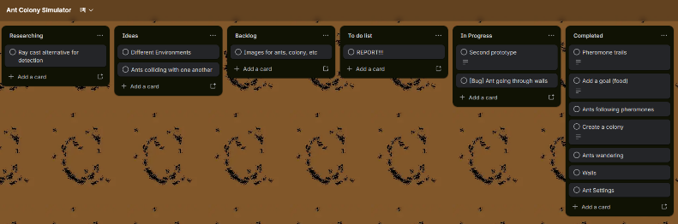
Tracking progress throughout the project will be invaluable, similar to choosing Agile and throwaway prototyping, choosing to use Kanban is natural. Both Gnatt charts and RAG reports require some prior knowledge. I cannot give a time estimate for Gnatt charts because with a lack of experience, I cannot know if a task is simple or not. RAG reports also need a clear distinction between red, amber and green; some items might end up being miscategorised. Therefore, using Kanban is the simple choice, a Trello board can be setup with the required bins, as well as bins for researching and debugging. I can do the tasks in order of importance, which can be determined with my current knowledge.
Figure 1. Kanban board using Trello, screenshot was taken 18/02/26
The first two months of the project (October-November) will be dedicated to researching how to use Unity and implementing basic ant agents, with little-to-no functionality. Once I am comfortable with the interface, I will move onto studying ACO such that by January, I will have ant agents that can collect food and return it to the colony autonomously. By the end of February, I should have an almost complete simulation environment, so that in March and April I can focus on finding results for my research question.

System Design
The primary objective of this project is to find an answer to the research question; to do so the system must meet the following functional requirements:
- Ant agents must be rendered.
- Ant agents must drop pheromones, which must evaporate over time.
- Ant agents must follow pheromone trails but must also have some degree of randomness to encourage exploration.
- Ant agents must find their own way to the goal – in this project, the goal will be food.
- The system must allow me to update the environments and switch between them.
The main non-functional requirement for this project is scalability. The execution must be efficient, even with thousands of ant agents.

Focusing on the ant agents, they should only know a few things about the environment, to better reflect the real world. Those are:
- Which colony they belong to.
- Where they currently are.
- If they are carrying food – if they are not, then they are yet to reach the goal state.
Ant agents will also be able to:
- Move around the environment with respect to walls and other obstacles.
- Deposit pheromones and follow other pheromone trails that belong to their own colony.
- See, pick up and deposit food once they return to the colony.
This initial set of functionalities will be enough for me to create a MVP and tune any and all parameters to better suit the simulation, one parameter to tune could be the pheromone evaporation rate. Scripts and algorithms will need to be designed around these requirements to correctly simulate the ant agents. These algorithms will be executed within Unity’s main loop, known as the Update function. This function is called for every frame – a single, completely rendered image and displayed on screen.
My main performance indicator for my simulation will be measured in frames per second (FPS), even though this will not affect the performance of the code itself, it is important to keep FPS high to keep the simulation looking smooth, but will also mean the simulation will, on average, take less time to reach a desired state. Another benefit to having a high FPS would be how much easier it makes spotting bugs due to the focus on visualising the simulation. Therefore, it will be a non-functional requirement to ensure the simulation performs at a high frame rate, anything above 30FPS will be acceptable, but I will be aiming to have more than 60FPS. These numbers were chosen from my experience in gaming and are considered an industry standard for video games.

Prototyping
My initial prototype used Unity’s Game Objects to create the ant agents, this approach let me focus on creating the artificial intelligence side of the simulation. For the pheromones, I also used Game Objects so that I could easily visualise the pheromones were being placed in the right places and they were evaporating correctly. However, this approach also meant I had to use ray casting, a technique which shoots a straight, invisible line (ray) in a specified direction from a point to detect collisions with objects. Every update cycle, every single ant agent would perform a ray cast in a ±45° cone from the centre of that ant agent with a radius of 2 units. The code would check for a food source, a colony, other ant agents and pheromones. This method is not very scalable, and the performance of the simulation showed, achieving ~20FPS with 100 ant agents. This prototype taught me that I needed to reduce the number of Game Objects, the two culprits of this performance loss are the ant agents and the pheromones. As such, I needed to figure out a method that could still be as functional as the first prototype with room to be better, while also being more performant and scalable.
As I decided to use throwaway prototyping, I started again from scratch, but instead of using Game Objects, I will make the ant agents entirely data driven. A single agent will only know its position, rotation, the colony it belongs to and if it is carrying food. These agents will be invisible, so they will need to render a sprite – this led me to meshes. Each ant agent is a data point with a quad mesh; the quad mesh was the simplest way to render the ants.
As for the pheromones, I decided to attempt a completely different method, I split the search space into a grid, ant agents would deposit the pheromones to the nearest cell of that grid. More pheromones would lead to a higher concentration, which is preferable for ACO as ants ‘tend to follow paths where pheromone concentration is higher’ (Dorigo, Birattari and Stutzle, 2006). This approach checks the pheromone concentration at 3 different angles: -30°, 0° and +30° of the ant agent’s current angle. Whichever direction is the most concentrated, the ant agent will move in that direction, with some degree of randomness. The simulation still uses Game Objects for the food and the colony, but there will not be thousands of Game Objects updating per frame. Ray casting is currently not being used as the distance between the ant agent’s current position and either the food sources or the colony can be used instead, however, I do plan to reintroduce raytracing to detect walls when I implement them. This raytracing won’t be as intensive as the distances of the rays will not be as large, so the performance impact will not be as large as the previous prototype.
After creating this second prototype, there was no loss of functionality, but the simulation was more scalable. The previous prototype simulated 100 ants, 1 colony and 1 food source (with additional Game Objects reserved using pooling for pheromones) achieved an average of 20FPS – lower than my 30FPS floor. In contrast, the second prototype simulated 1,000 ants, 1 colony and 1 food source, a total of 2 Game Objects achieved upwards of 100FPS, on average a 400% increase in performance. From this prototyping stage, I learned that I must reduce the number of Game Objects and ray casting, while ensuring any further modifications do not compromise on functionality.
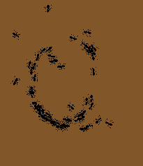
Both prototypes did produce ant milling, as such I could assume they were accurate, shown in Figure 1. These ant agents are stuck going round in circles as their pheromone trails keep reinforcing the roundabout motion. Soon after the ant agents managed to free themselves from the milling, usually this happens when an external ant agent creates a new pheromone trail, or the randomness within the simulation causes them to break free.
Figure 2. Ant milling in the simulation
However, by moving to this second prototype, I had to retune all of the settings to fit this simulation, especially because the search space became larger, while the ant agents became smaller. This meant that the ant agent’s speed, sense distance, pheromone drop rate and decay rate, and the randomness of the agents themselves all became incorrect. This took some time to complete but was a necessity in order to achieve a successful simulation.

Simulation Development
After finishing the prototyping stage, the simulation looked promising. Ant agents could move around the search space, follow trails and locate food, whilst also being able to return home. The next step was to introduce walls, rather than the ant agents being allowed to move freely, they should be confined, which would allow me to create unique environments where I can test what complexities most affect problem-solving efficiencies. Putting walls into the simulation was easy, Unity has a Tilemap system, where you can place a tile from a tileset onto a 2D grid. Typically, with Game Objects the walls would act as walls, but since my ant agents are data points, I must create this functionality myself. As mentioned earlier, ray casting is the easiest method to create the functionality I need.
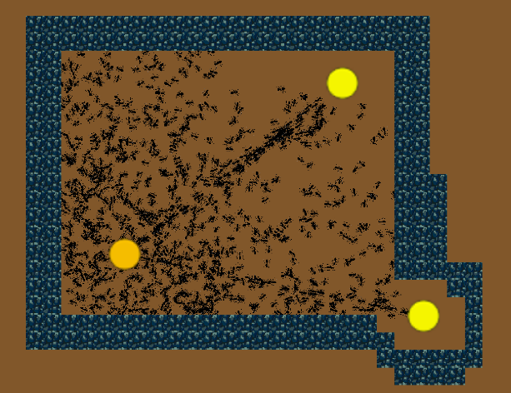
The ObstacleAhead(Ant ant) function works by calculating the unit direction the ant agent was moving in, then a ray cast would be used to determine if there was an obstacle ahead, obstacles are the umbrella term I will be using for impassable terrain, such as walls, rocks, boulders. If there was an obstacle ahead, the ant would move towards the colony, which I had intended to replace with turning left or right.
Figure 3. Ant agents sometimes moving through walls. The bottom left circle is the nest and the two circles on the right are food sources.
Upon completing this code, the ant agents seemed to be staying within the walls effectively. But upon closer inspection of Figure 1, I noticed that sometimes the ants were clipping through the walls. At first, I couldn’t determine what had caused this bug, I thought it was due to too low of an obstacleAvoidanceDistance, so I kept increasing it but to no avail.
I decided to redo the ObstacleAhead(Ant ant) function and I had noticed that when calculating the unit direction the ant agent was moving, I was using the sine of the ant agent’s angle as the X component of the vector and the cosine of the ant agent's angle as the Y component of the vector. According to the Pythagorean trigonometric identity, the X component is the cosine of the angle, and the Y component is the sine of the angle (Hungerford, 2009). This means that the ray cast was perpendicular to the ant agent’s direction of movement. Along with fixing this bug, I decided to check if there were any walls to the left or right of the ant, just to make the function more robust. The code also checks for if the ant agent is within a wall by using a very short ray cast, if the ant agent is within a wall, the ant agent would be teleported to the colony instead.
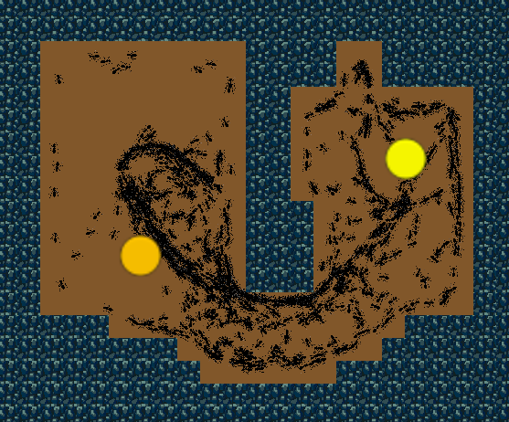
Jackson and Ratnieks’ study in 2006 suggests that an ant ‘colony forms a trail when successful foragers deposit pheromone on their return to the nest’ and that self-reinforcement of that trail is based on more ants using that trail. My current solution had the ant agents drop two kinds of pheromones, one when they were searching for food – represented when the Boolean value carryingFood is false, and another pheromone when they are returning to the colony – when carryingFood is true. This implementation is the opposite of what Jackson and Ratnieks found. Considering this, I decided to update my code such that the ant agents follow the opposite trails. If the ant is heading towards the food source, then follow the trails of those ants that are returning from the food source. This change led to a good balance of exploration and exploitation of the environment, movement was random while the ants were searching for food, but once an ant agent found the food, nearby ants would follow the returning trail, until almost all of the ants join the trail.
Figure 4. Ant agents moving to the food (yellow circle, right) from the colony (darker yellow circle, left) and back. Some ant agents showing preference to the wall.
I had also noticed that the ant agents tend to follow alongside the walls, almost as if they are hugging them. This behaviour seems consistent with ant behaviour I have noticed in real life. This behaviour is similar to what Dussutour, Jean-Louis Deneubourg and Fourcassié (2005) found, ‘in 16 out of 19 experiments, the ants showed a clear preference for the branch with the wall’. Seeing emergent behaviour from the simulation such as this, mimicking real life ants, shows that the simulation is reliable.

Testing Methodology
There is enough functionality to move on to testing the simulation and finding results for the research question. My testing methodology will be creating various environments with various amounts of colonies and food sources.

What is Tested | Environment Design | Number of Colonies | Number of Food Sources
Does directionality affect ACO? | Large open area | 1 colony, in the middle | 4 food sources in each corner
Do obstacles get affected by directionality? | Two sides mirrored with obstacles | 2 colonies, on either side | 1 in the middle
How quickly are efficient paths formed? | A maze | 1 colony | 1 food source
Which food source gets exploited first, closest or more accessible? | Left-side with high density of obstacles, right-side more open but further | 1 colony, in the middle | 2 food sources, on either side
Table 1. The test set with an overview of the environment type and how many colonies.
The first few tests will give me a baseline for how my simulation performs, then I can move on to testing in context to vehicle routing, networking, Mars rovers, etc. The environment design will try to mimic the environments in which the test is meant for, a maze can roughly be equated to a city’s complex road networks, high density of obstacles on one side but further away on the other can be equated with network rerouting.
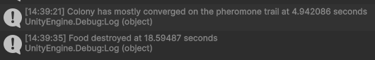
There will be two main measurements for this testing, the first which can be coded, but the second will have to be done manually, due to the ant agents being data points and not coded as Game Objects. The first measurement will be how long it takes for the Ant Agents to exhaust the food supply; this can be done by adding a lifetime float to the food sources and every frame increase this float by 1/FPS, for instance at 60 FPS, the increment would be 0.01667 seconds. This can be done by adding Unity’s Time.deltaTime to the lifetime float every frame. The second measurement will be how long it takes the ant agents to mostly converge into one trail; this can be done using the same method but will require manual input in order to record the time taken. I can code it such that when a key is pressed, the lifetime of the ant colony will be printed out to the console. Figure 4 shows what the outputs would look like, ‘Colony’ and ‘Food’ are tied to the names of the Game Object in the editor, so for instance I can name the colony ‘Colony top right’ in order to identify it easier.
Figure 5. The console outputs of how measurements will be obtained.

Testing & Results
All tests will have a various number of food sources and colonies, each food source will have 100 individual foods, and each colony will have 1,000 ant agents. As mentioned above, the first few tests will be to establish a baseline. Each test be run at least 3 times and will end at 400 seconds, regardless of if the food sources were depleted or if the food made it back to the colony.

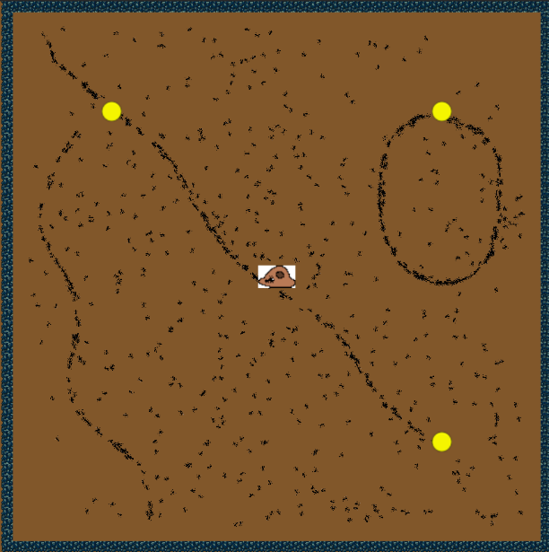
Directionality Testing
Figure 6. The first directionality test.
The first test will be if directionality has any effect on the simulation.
During the first simulation, after 167.48 seconds the noise of the simulation cleared, showing pathways, as well as the bottom left food source being depleted. Figure 5 shows a clear pathway between where the bottom left food source as and top left food source, as well as the bottom right and the top left food sources. There is also clear ant milling at the top right food source. But there aren’t many paths back to the colony, as such the colony only had received 23 foods from all of the food sources. After another 40 seconds, all of the other food sources were also depleted, with the top left and the top right both being depleted within 1 second of each other. After the 400 seconds, only 81 foods were received by the colony, this could be an issue with the simulation, or the food could be stuck inside the mill in the top right corner.
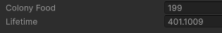
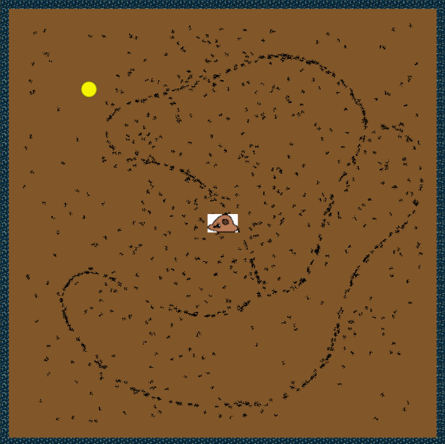
During the second test, after 100 seconds, pathways started forming with the first food being received after 125 seconds. At 160.52 seconds, the bottom left food source was depleted and at 174.39 seconds, the top right food source was depleted. At this point in time, no pathway leads to either of the other food sources, but they both have less than 15 foods left each. At 287.21 seconds, the bottom right food source was depleted by ant agents who weren’t on the main ‘highway’, but the colony had received much more food. 20 seconds later, the final food source was also depleted. After the 400 seconds, the colony had received half of the available food, implying that the milling seen in the first test is the reason for the low intake.
Figure 8. Test 2’s colony having 200 foods after 400 seconds.
Figure 7. Test second directionality test.
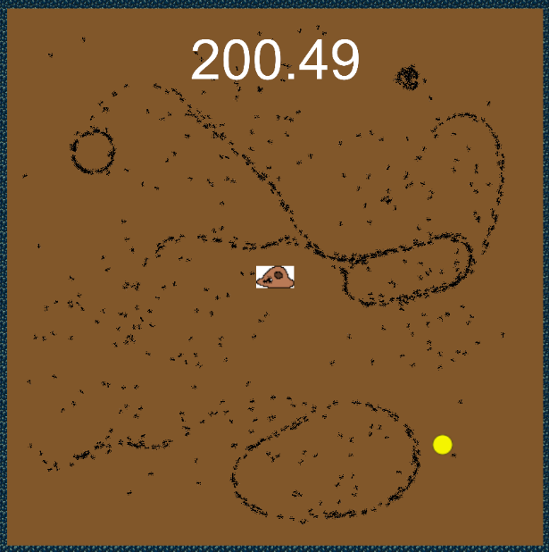
For the third test, I added a timer on screen, so it is easier to see when the screenshots were taken. This was done by using the same lifetime float as before. After 200 seconds, although 3 of the food sources were depleted, there is a lot of milling. As such the colony has only received 1 food. This didn’t improve much over the next 200 seconds, but as found by Delsuc (2003), this is a feature not a bug. At 323.46 seconds, the top left mill combined with the middle right mill, nothing else interesting happened during this test.
These 3 tests show that directionality does not affect the performance of my ACO implementation, it also shows that more time is needed to return the food back to the colonies, unless they get stuck in a mill, in which case, it is unlikely for the ant agents to return to the colony, reducing the performance of the simulation.
Figure 9. Test 3, a lot of milling.

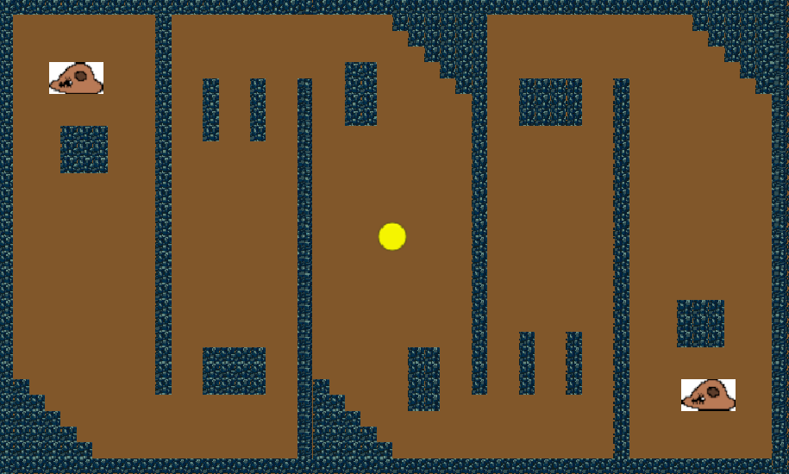
Obstacles and Directionality Testing
Figure 10. The testing environment of Obstacles and Directionality Testing.
Figure 9 shows the environment in which this testing will be conducted. Both sides are mirrored and opposite, this will test if adding obstacles will affect the directionality of the simulation. As in the previous test, there is no evidence to suggest that it will, however, to get a good baseline, I will also test this 3 times with a time limit of 400 seconds. It should be noted that ant agents of colony A will not follow the pheromone trails that belong to colony B
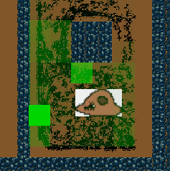
In the first test, at around 100 seconds both colonies reached the food source, at 222.38 seconds the food source was depleted. Within 40 seconds one ant agent had returned to the right colony with the first food delivery. By 400 seconds, this was still the only food returned to the colony. To help with the testing of this, I added code which allows me to visualise the pheromone trails using Unity’s Gizmos system, a visual debugging API. Now, when I click on a colony, I can see where pheromones roughly are and how concentrated they are, as seen in Figure 10.
Figure 11. Pheromones as seen by Gizmos.
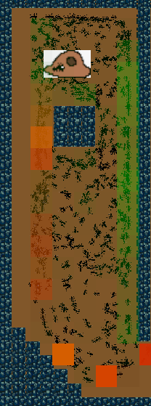
This time, the first food was taken at 80 seconds by an ant agent belonging to the left colony as shown by red pheromone trails. By 140 seconds, 35 foods have been taken between both colonies, but some ants were getting stuck going towards the opposite colony. Figure 11 shows the pheromone trails of the left colony, the green trails are left by ant agents without food, while the red/orange trails are left by the ant agents carrying food. There is a bias that ants follow the opposite trail of which they are leaving, so they can find their way to and from the colony or food source. This trail is highly effective as at this point in the simulation, 242.10 seconds, the left colony received 10 foods, while the right colony received 2. Some of the left colony’s ant agents were stranded on the right-side of the simulation, while the right colony’s ant agents were either in the middle or on their side, but they were struggling to find their way back home. In the last 160 seconds, no more ants managed to make it home.
Figure 12. Pheromone trails.
In the third test, the performance was like the previous one, by 200 seconds the food source had been depleted, and colonies were struggling to get the food they obtained. This could be attributed to either the testing environment being too difficult, or the settings not being tuned well enough. However, in all 3 of these tests, there was no ant milling, besides ants going around the first rock. An emergent behaviour discovered previously by Dussutour, Jean-Louis Deneubourg and Fourcassié (2005).
While I have proved that obstacles have no impact on directionality with these tests, they have also revealed that my settings aren’t well tuned enough to provide a definitive answer for my research question. Due to the tight deadline of the project, I must continue onwards, now knowing that my results will not be the best they can be.

Speed of Forming Efficient Paths
The idea of this test is to see how long it takes to form an efficient pathway, as this simulation uses ACO, eventually an efficient pathway will be formed. But based on how slowly the ant agents made their way to the centre food source in the previous test, rather than being a maze, this test will be a straightforward, long pathway. This test will also adjust the previously stated parameters; there will still be 1,000 ant agents per colony, however, the single food source will have enough food such that it will not run out while the ant agents are forming pathways, I have chosen 100,000. Finally, there 400 second limit will be removed, this time, the simulation will run until a pathway is formed. It is likely this simulation will take too long for the deadline so this will only be run once.
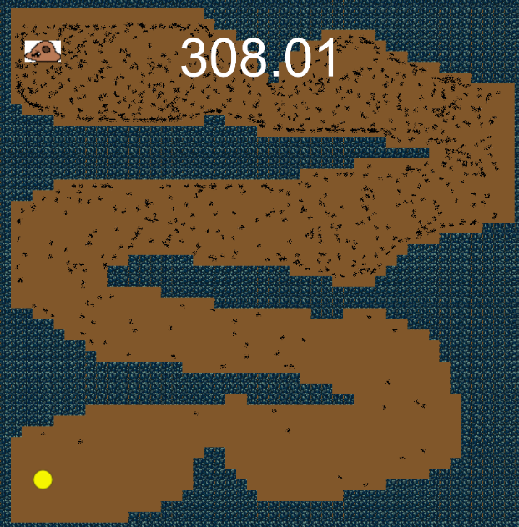
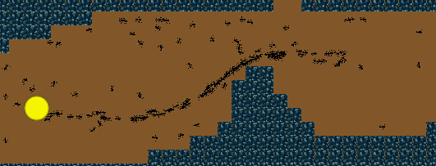
By 200 seconds, a few ants had made it to the final stretch, many ants still were stuck near the colony, while the second and third corridors were filled with decreasing ant agents. This behaviour is intuitive as regions further away from the colony will naturally be explored less than regions closer to the colony. Figure 12 shows what the simulation looks like around the 300 second mark. More ant agents are making their way into the later corridors, but no ant agents have found the food source despite there being nearby ants. Within 30 seconds of this screenshot, around 340 seconds, the first ant agent has found the food source and is on route back to the colony. This should promote more ant agents to find the food source due to the pheromone trails it leaves behind, the opposite is also true, the ant agent carrying the food should be able to find its way back to the colony because of the other ants. This positive feedback loop is essential to forming efficient pathways.
Figure 13. Testing the speed of forming efficient pathways.
At around 660 seconds, many ants had started forming a pathway away from the food source, this was promising as it shows more ant agents were soon to join on this congaline towards the food source, as long as they do not get stuck in an ant mill somewhere along the path back to their colony.
Figure 14. The beginnings of a pathway.
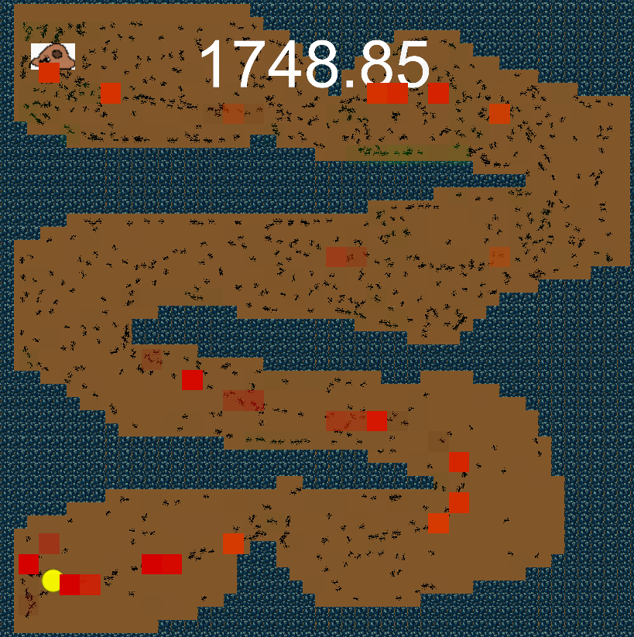
By 1,750 seconds, a pathway is beginning to form as shown by the red pheromones in Figure 14. It will take some more time before more ants join and continue down this pathway, but this development shows that pathways are able to be formed during this simulation, and by looking at the distance to the inside of the corner, the ant agents are already taking efficient pathways.
Figure 15. The pathway from the food source to the colony.
After 3,000 seconds, more ant agents joined the pathway formed previously, slowly improving the cornering overtime to some time travelling back and forth. All of the corners became tighter, almost as if the ant agents were hugging the walls. I decided to stop the simulation here and there wasn’t much more room for improvement and due wanting to stick to my deadline.
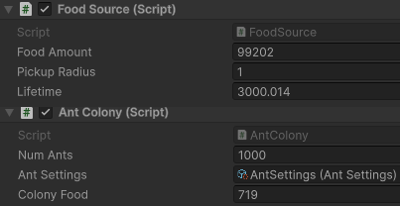
I paused the simulation at this point and compared the number of foods that had left the food source with the number of food in the colony, both shown inside of the Unity Editor when I click on the Game Object which the script is attached to. Figure 15 shows the time in the Lifetime variable, the food left in the food source in Food Amount and the food in the colony under Colony Food. Of the initial 100,000 food, 99,202 remained within the food source, this means that 798 food had been collected by the 1,000 ants. On the other side, 719 food had been collected at the colony. Therefore, only 79 food had been collected and not yet delivered. Some ants were still travelling between the food source and the colony, and not all ant agents had joined the pathway. This is likely the cause of 79 foods still being uncolected.
Figure 16. The variables behind the scenes of the simulation.
With the first food being collected around 310 seconds and the first semblance of a pathway being formed at 340 seconds, then a pathway to the colony from the food source forming before 1,750 seconds and further refining itself until, and likely after, 3,000 seconds shows that this simulation will eventually exhaust the food supply while performance only improved over time as the ACO algorithms take centre stage, the heart of whats refining the pathways.

Accessibilty Testing
This test can go back to the original parameters, 1,000 ants, 100 foods and 400 seconds. I have also learned that bigger, more open areas lead to more milling in this simulation. This functionality might not be representative of real-life ants, so I shall attempt to limit the number of open areas by adding in more obstacles.
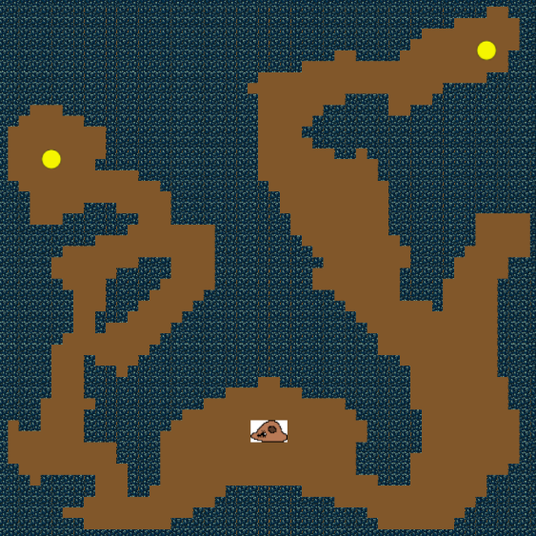
Figure 16 shows the environmental design for this test; the ant agents should equally split in both direction until pheromone trails are formed. This test is to see if there is a preference in how accessible an area is, my prediction is that the proximity is the main factor rather than complexity. I expect the ant agents to find both food sources around the same time but return home quicker from the left-side due to it being physically closer to the colony.
Figure 17. Accessibility Testing environment.
In the first test, around 80 seconds in, the left-side had reached the food source while on the right there were a couple of ants slowly making their way towards it. The pheromone trails left behind on the left-side caused a lot more ants to find the food source, meanwhile the right-side was still slowly getting started. At around 150 seconds, the left-side seemed to have got stuck milling around the central rock, while the right-side had started to get their journey back to the colony underway, with little to get stuck on it is likely for the right-side to get back to the colony quicker. At 248.06 seconds, the left food source was exhausted, but the colony has received 0 food, it was all stuck in the complexity of the environment. Meanwhile, on the right-side, the ants were just around the corner to start depositing their food. Within 60 seconds, the left-side had also become unstuck and made its way around the corner of the colony and was the first side to deposit food. Another 30 seconds after the right-side had been exhausted, but with only 50 seconds left in the test, this time the closer, but more complicated route seemed to come ahead.
In the second test, by 200 seconds the left-side did not get stuck milling around the rock and instead made their way back to the colony and had deposited their food. At this time, the right-side was still starting to form their pathway from their food source. By 260 seconds, the right-side started milling and the 50 seconds later the left-side had exhausted their food source. By the end of the 400 seconds, the right-side still had 14 foods left, and the left-side had returned 23 foods, once again proximity seems to be the favoured trait in this simulation.
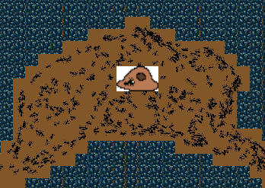
The third test was also consistent with the previous two, the left-side finds the food source earlier than the right and returns to the colony around the time the right-side pathway begins forming. Across all three tests, many ants were stuck in the initial room around the colony. This issue likely harmed the results, but as it was consistent across all three tests the results should have averaged out. This could have been fixed by instead doing this test with two colonies, one dedicated to the straightforward but longer path, and the other dedicated to the shorter but more complicated path.
Figure 18. Ants stuck in the initial room.
This test has shown that there is no inherent preference for which way the simulation chooses to exploit first. The direction which is shorter will be exploited first as it is simply found first by ACO. However, this is likely to be untrue if the shorter side is complex in such a way that its length is equal to the length of the simpler side. This is an idea I attempted to implement in this test, but designing such an environment would’ve taken too much time to create manually.

Evaluation
The result of my testing shows that there is potential for ACO to be useful in real-world situations, although it is slow on the uptake, once a pathway is found it is constantly refined and improved, within the bounds of the environment. For instance, with self-driving vehicles, ACO could be a part of the AI behind the scenes, it is able to dynamically adjust its pathing on favourable pathways when obstacles obstruct the ideal pathway, an essential feature for driving on roads where pedestrians and other road users can suddenly pull out in front of your vehicle. But as ACO does take some time to find the initial pathway, it would mean that a lot of calculations would need to be done before driving started, so that there are no random, jerky movements from the randomness that is baked into ACO. However, in the short term, this can be used to speed up finding delivery routes and approximating when a package should arrive, with some adjustments, each drop-off location can be a goal state and the ACO algorithms can find the shortest path between them all, then returning to the depot. This is also an adjusted variant of the Travelling Salesman Problem, a problem which ACO is known for being good at solving.
Network navigation, however, could see some improvements in speed of finding efficient paths, that will only improve as time goes on. When a previous pathway becomes congested due to not enough bandwidth, having an algorithm like ACO working in the background could help route data flow more efficiently as time goes on, leading to more consistent dataflow, increased internet speeds and more stable connections. However, my simulation may not support these findings as it focuses more on the agents being allowed to travel in any direction, not just towards the next junction like how a network would be set up. In such an environment, the agents would not find themselves milling or getting stuck, it would be similar to a road network and would need similar adjustments made to the functionality in order to see benefits in this area.
Finally, this type of simulation could easily have massive impacts on space agencies such as NASA. Streamlining the process of rover exploration on astronomical bodies like the Moon and Mars would allow humanity to learn more about the universe, understanding how the Earth was formed, while also attempting to answer other questions, like if we are alone in the universe. Reducing the cost of these missions would allow such organisations to carry out more missions, each time leading us closer to the answer to the many questions we have about our universe.
Overall, how does environmental complexity affect problem-solving efficiency in ant colony systems? The agents managed to successfully navigate through a more complicated, but shorter environment quicker than navigating through a more linear, but longer environment. But the agents did sometimes find themselves stuck, this issue is likely to do with the settings of the ants and their pheromones, if I were to continue working on this project, then I could refine the settings and manage to get more realistic settings, where the ants find themselves stuck less frequently, but can also adapt and navigate more effectively. Given more time, the experiments and testing could’ve been more in depth, allowing more clarity on my findings to show they weren’t one offs. My findings did manage to successfully show that ant colonies were well-equipped to deal with the environmental complexities, but they might not be convincing enough.

Conclusion
My simulation, although provided seemingly valid results, did not seem to be properly well tuned while testing, which could’ve skewed, but it is not likely to have provided bad results as everything was consistent with how I expect ACO to behave in those situations. Further development into this project will lead to more validity in my findings, I would do this by continuing to refine my settings across my current testing environments. Then I would expand the search space I have already allocated and produce even more complicated environments, comparing the efficiency and speed of the two versions will definitively answer my research question, rather than it currently being a bit ambiguous.
This project has shown that ACO is still an effective strategy, even though Marco Dorigo first proposed the idea in 1992. The modern version of these older algorithms is invaluable to modern problems, “If it ain’t broke, don’t fix it”, finding new ways to solve problems we have already solved could end up being fruitful, but starting from scratch will only lead to increased business costs as well as wasted time and effort. Further study of ACO will be simpler and will provide results faster, something that businesses prioritise more as AI takes over their operating procedures.
During this process, I have faced many difficulties. Most of which I was able to overcome by researching more into Unity and everything surrounding it. Such as when I moved onto my second prototype, moving away from Game Objects allowed me to create a more responsive, more flexible simulation. However, it also meant that I had to find a nuanced way to do something that was once simple, due to the ants and pheromones not using Unity’s features. This made me wonder if Unity was the best choice for this simulation, despite one of my requirements being the ability to visualise the simulation. Sticking with Unity did allow me to continue working to the best of my ability as I was interested in how to use the software, finishing this project has given me that ability and will be helpful in the future, even if I do not work with Unity.

References
Dorigo, M., Birattari, M. and Stutzle, T. (2006). Ant colony optimization. IEEE Computational Intelligence Magazine 1(4), pp.28–39. https://ieeexplore.ieee.org/document/4129846
‌de Vries-Gao, A. (2025). The carbon and water footprints of data centers and what this could mean for artificial intelligence. Patterns, p.101430. doi: https://doi.org/10.1016/j.patter.2025.101430
‌Slota, S.C., Fleischmann, K.R., Greenberg, S., Verma, N., Cummings, B., Li, L. and Shenefiel, C. (2020). Good systems, bad data?: Interpretations of AI hype and failures. Proceedings of the Association for Information Science and Technology, 57(1). doi: https://doi.org/10.1002/pra2.275
Dahiya, C. and Sangwan, S. (2018). Literature Review on Travelling Salesman Problem. International Journal of Research. Available at: https://www.academia.edu/101536364/Literature_Review_on_Travelling_Salesman_Problem
‌ Michelakos, I., Mallios, N., Papageorgiou, E. and Vassilakopoulos, M. (2011). Ant Colony Optimization and Data Mining. Studies in Computational Intelligence, pp.31–60. doi: https://doi.org/10.1007/978-3-642-20344-2_2
Delsuc, F. (2003). Army Ants Trapped by Their Evolutionary History. PLoS Biology, 1(2), p.e37. doi: https://doi.org/10.1371/journal.pbio.0000037
NASA (2025). Moon to Mars Architecture. Available at: https://www.nasa.gov/wp-content/uploads/2025/12/2025-architecture-update-for-publication.pdf?emrc=69b979a71d6db
Zhang, Y., Wang, S. and Ji, G. (2013). A Rule-Based Model for Bankruptcy Prediction Based on an Improved Genetic Ant Colony Algorithm. Mathematical Problems in Engineering, 2013, pp.1–10. doi: https://doi.org/10.1155/2013/753251
Beck, K., Beedle, M., van Bennekum, A., Cockburn, A., Cunningham, W., Fowler, M., Grenning, J., Highsmith, J., Hunt, A., Jeffries, R., Kern, J., Marick, B., Martin, R.C., Mellor, S., Schwaber, K., Sutherland, J. and Thomas, D. (2001). Manifesto for agile software development. Agile Manifesto. Available at: https://agilemanifesto.org/
Wendt, S., Kleinhoelting, N. and Czaczkes, T.J. (2020). Negative feedback: ants choose unoccupied over occupied food sources and lay more pheromone to them. Journal of The Royal Society Interface. doi: https://doi.org/10.1098/rsif.2019.0661
Jackson, D.E. and Ratnieks, F.L.W. (2006). Communication in ants. Current Biology, 16(15), pp. R570–R574. doi: https://doi.org/10.1016/j.cub.2006.07.015
Hungerford, T.W. (2009). Contemporary Precalculus: A Graphing Approach. Belmont, Ca: Thomson Brooks/Cole. P. 442 ISBN 978-0-495-10833-7
Dussutour, A., Jean-Louis Deneubourg and Fourcassié, V. (2005). Amplification of individual preferences in a social context: the case of wall-following in ants. Proceedings of The Royal Society B: Biological Sciences, 272(1564), pp.705–714. doi: https://doi.org/10.1098/rspb.2004.2990

Appendix

Figure 1. Kanban board using Trello, screenshot was taken 18/02/26


Figure 2. Ant milling in the simulation


Figure 3. Ant agents sometimes moving through walls. The bottom left circle is the nest and the two circles on the right are food sources.


Figure 4. Ant agents moving to the food (yellow circle, right) from the colony (darker yellow circle, left) and back. Some ant agents showing preference to the wall.

Figure 5. The console outputs of how measurements will be obtained.
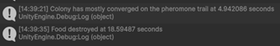


Figure 6. The first directionality test.


Figure 7. The second directionality test.

Figure 8. Test 2’s colony having 200 foods after 400 seconds.
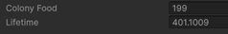

Figure 9. Test 3, a lot of milling.

Figure 10. The testing environment of Obstacles and Directionality Testing.
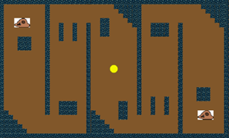


Figure 11. Pheromones as seen by Gizmos.

Figure 12. Pheromone Trails

Figure 13. Testing the speed of forming efficient pathways.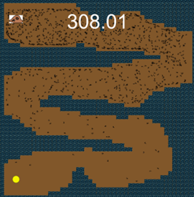
Figure 14. The beginnings of a pathway.
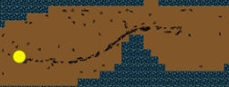
Figure 15. The pathway from the food source to the colony.
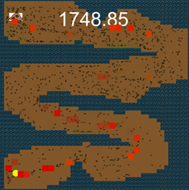
Figure 16. The variables behind the scenes of the simulation.
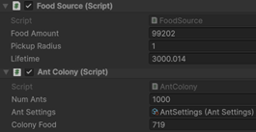
Figure 17. Accessibility Testing environment.
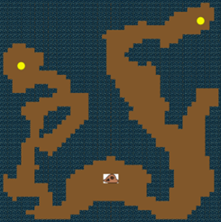

Figure 18. Ants stuck in the initial room.

Table 1. The test set with an overview of the environment type and how many colonies.
What is Tested | Environment Design | Number of Colonies | Number of Food Sources
Does directionality affect ACO? | Large open area | 1 colony, in the middle | 4 food sources in each corner
Do obstacles get affected by directionality? | Two sides mirrored with obstacles | 2 colonies, on either side | 1 in the middle
How quickly are efficient paths formed? | A maze | 1 colony | 1 food source
Which food source gets exploited first, closest or more accessible? | Left-side with high density of obstacles, right-side more open but further | 1 colony, in the middle | 2 food sources, on either side

Assets
Tilemap - https://smallmak.itch.io/creepy-cave-tileset
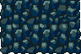
Ant sprite - https://www.vecteezy.com/vector-art/68250945-detailed-silhouette-of-a-common-black-ant-facing-upwards
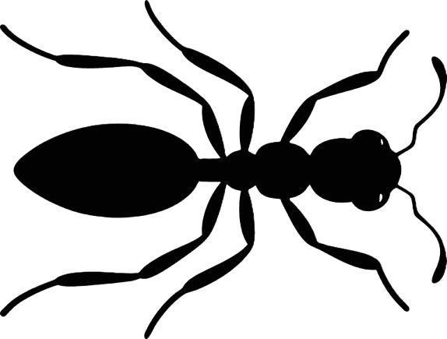
AntColony – Drawn by me using MS Paint

Resources
GitHub Repo: https://github.com/Synced47/AntColonySimulator2
Simulation inspired by: https://youtu.be/hTHpEF_jcu4
Unity NavMesh YouTube research: https://youtu.be/G9Otw12OUvE

